Term 2 - Week 8 - Quiz

Introduction to Dealing with Conflict
Summarise three points that you took away from the two videos and the Bible passage above.
☐ Satisfactory  ☐ Not Yet Satisfactory | Assessor Feedback:

Jesus’ response to Conflict resolution
Outline under the following headings what this looks like:

- Do it quickly (Matthew 5:23-25)
- Face to face (Matthew 18:15)
- One on one (Matthew 18:15)
- Get help (Matthew 18:16-17)
☐ Satisfactory  ☐ Not Yet Satisfactory | Assessor Feedback:

What is Your Response to Conflict?
Recall the following from the Week 2 Introductory quiz:

Different types of questions:
- Now: What is going on?
- Why: Why is this going on?
- New: What ought to be going on?
- How: How might we respond?

Different styles of questions
- Closed questions
- Open questions
- Probing questions
- Leading questions
- Loaded questions

How could these have helped you to better resolve conflicts?
☐ Satisfactory  ☐ Not Yet Satisfactory | Assessor Feedback:

Application
Share this with the rest of the Discipleship Group and share ideas about how this could have been resolved differently using different questions or problem solving techniques. Record what you have discussed in relation to your situation below.
☐ Satisfactory  ☐ Not Yet Satisfactory | Assessor Feedback:

Resolving a Conflict in your Primary Ministry Placement
Think of a current conflict in your Ministry Placement. What is it?
☐ Satisfactory  ☐ Not Yet Satisfactory | Assessor Feedback:

Think about how you could approach this resolving this conflict. What basic problem solving technique could you apply?
☐ Satisfactory  ☐ Not Yet Satisfactory | Assessor Feedback:

What questions could you ask in order to resolve the situation? Run these by your teacher, Discipleship Group or Ministry Placement Supervisor for advice?
☐ Satisfactory  ☐ Not Yet Satisfactory | Assessor Feedback:

After sharing some ideas with other, develop a list of questions that you will ask to consolidate your knowledge about this issue.
☐ Satisfactory  ☐ Not Yet Satisfactory | Assessor Feedback:

Ask these questions to the person involved. How did this go?
☐ Satisfactory  ☐ Not Yet Satisfactory | Assessor Feedback:

What was their response to these questions?
☐ Satisfactory  ☐ Not Yet Satisfactory | Assessor Feedback:

What were some clarifying questions that you asked during this conversation?
☐ Satisfactory  ☐ Not Yet Satisfactory | Assessor Feedback:

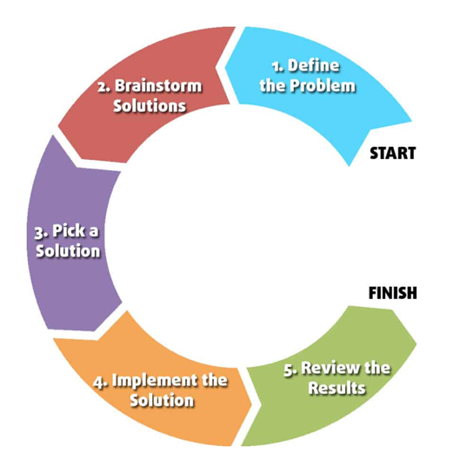
What resolution did you come up with together? (Include how you applied basic problem-solving techniques)

☐ Satisfactory  ☐ Not Yet Satisfactory | Assessor Feedback:

What were some challenges that you had with the types of questions, styles of questioning and problem solving?
☐ Satisfactory  ☐ Not Yet Satisfactory | Assessor Feedback:

Seek feedback from your Ministry Placement Supervisor about questions and problem-solving technique. Record their feedback below.
☐ Satisfactory  ☐ Not Yet Satisfactory | Assessor Feedback:

In consultation with your Ministry Placement Supervisor, how could you have improved the problem-solving process?
☐ Satisfactory  ☐ Not Yet Satisfactory | Assessor Feedback:

Quiz - Term 2 Week 8
Overall performance | ☐ Satisfactory  ☐ Not Yet Satisfactory | Trainer:
Overall performance | ☐ Satisfactory  ☐ Not Yet Satisfactory | Signature:
Overall performance | ☐ Satisfactory  ☐ Not Yet Satisfactory | Date:
Comments

