Term -2- Week 1 - Quiz

Introduction
Outline the five ways that people view Christ and Culture.
☐ Satisfactory  ☐ Not Yet Satisfactory | Assessor Feedback:

What way is put forward as the best way for Christian’s engaging with culture? Why?
☐ Satisfactory  ☐ Not Yet Satisfactory | Assessor Feedback:

Christianity in Australia
- After looking at the infographics about Faith in Australia, what three things stood out to you most?
☐ Satisfactory  ☐ Not Yet Satisfactory | Assessor Feedback:

- What does this tell us about how we should engage with Australian Culture?
☐ Satisfactory  ☐ Not Yet Satisfactory | Assessor Feedback:

Exegesis Activity
1. The World Behind the Text
A. Open your Study Bible to the Introductory Notes for Acts. Identify information about who, what, where, and when, and record any relevant information about the book of Acts generally.

- Who is it written to:
- What was happening:
- Where is it written:
- When was it written:
☐ Satisfactory  ☐ Not Yet Satisfactory | Assessor Feedback:

B. Who is the author?
☐ Satisfactory  ☐ Not Yet Satisfactory | Assessor Feedback:

2. The World of the Text
A. Within the book, where does this passage take place? How do they relate to the Big Picture?
☐ Satisfactory  ☐ Not Yet Satisfactory | Assessor Feedback:

B. What keywords, phrases, or themes need further exploration?
☐ Satisfactory  ☐ Not Yet Satisfactory | Assessor Feedback:

C. Using the reference and index sections, who was Peter preaching to in Acts 2 and who Is Paul preaching to in Acts 17?
☐ Satisfactory  ☐ Not Yet Satisfactory | Assessor Feedback:

D. Identify other Christian sources (Websites, books, person, video) to help you answer the following questions. Reference the sources you have used. You can start with the following:
☐ Satisfactory  ☐ Not Yet Satisfactory | Assessor Feedback:

E. Acts 2:14-36.
• What are some key features that you notice about how Peter preached the gospel?
• After hearing this sermon, how did they respond?
• Why would this method have been effective to this audience?
☐ Satisfactory  ☐ Not Yet Satisfactory | Assessor Feedback:

F. Acts 17: 16-34.
- Do you notice anything different to Acts 2? What was the response?
- Read Acts 17:22-27, how does Paul engage with the Greek culture?
☐ Satisfactory  ☐ Not Yet Satisfactory | Assessor Feedback:

G. Locate specific passages in the Old Testament and New Testament that provide meaning to some of the words and themes.
☐ Satisfactory  ☐ Not Yet Satisfactory | Assessor Feedback:

H. Acts 17: 16-34.
• Read 1 Corinthians 1: 23, Why was it foolishness to the Greeks?
• The Israelites adopted the false religions of surrounding nations and often added to their beliefs to the Jewish faith. What happened? Examples Deuteronomy 9: 7-29; 1 Samuel 8
☐ Satisfactory  ☐ Not Yet Satisfactory | Assessor Feedback:

I. Locate at least 2 different biblical tools that could be used to understand this passage. List them below.

Examples: Bible dictionaries and encyclopedias, commentaries, concordances, various Bible translations and paraphrases, lexicons of original Greek and Hebrew words, Bible atlas, systematic theology textbooks, Bible study computer programs)
☐ Satisfactory  ☐ Not Yet Satisfactory | Assessor Feedback:

Citing Sources:
J. Acknowledge the sources that you have used by referencing them below.
☐ Satisfactory  ☐ Not Yet Satisfactory | Assessor Feedback:

K. For each source, explain the different information they provide and how each source has helped you to understand this text
☐ Satisfactory  ☐ Not Yet Satisfactory | Assessor Feedback:

L. Under each reference, identify different quotes found in each source that capture the theological view.
☐ Satisfactory  ☐ Not Yet Satisfactory | Assessor Feedback:

M. Describe in your own words, what the current theological view on this passage is.
☐ Satisfactory  ☐ Not Yet Satisfactory | Assessor Feedback:

The World in Front of the Text
A. What could be the ancient reader’s response to this passage?
☐ Satisfactory  ☐ Not Yet Satisfactory | Assessor Feedback:

B. What might this passage be saying to the modern culture with reference to its context?
☐ Satisfactory  ☐ Not Yet Satisfactory | Assessor Feedback:

C. Why did this happen in Acts 2, but not in Australia today? (Why don’t we see more gatherings where thousands of people are seen falling on their knees before a Holy God, repent of their sin, be saved, and go and influence the culture with the Christian message?)
☐ Satisfactory  ☐ Not Yet Satisfactory | Assessor Feedback:

D. Looking at the way Paul interacted with people in the Athenian culture, what can we learn about how to effectively engage and communicate with those in our Australian culture?
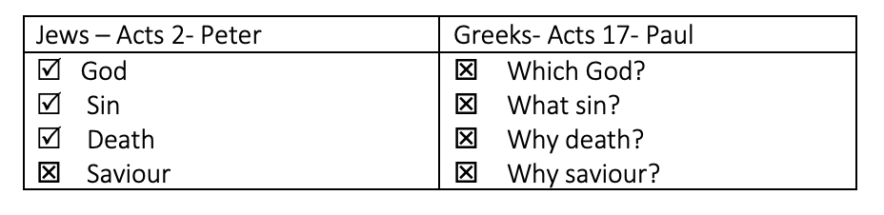

☐ Satisfactory  ☐ Not Yet Satisfactory | Assessor Feedback:

E. What does this passage mean for the Church? What is it saying to me personally?
☐ Satisfactory  ☐ Not Yet Satisfactory | Assessor Feedback:

F. Answer one of the following questions:
• How do we see this happening in the Church today?
• How is this similar to the Australian culture today?
• What happens when our thinking is not based on God’s Word?
☐ Satisfactory  ☐ Not Yet Satisfactory | Assessor Feedback:

G. Was this approach helpful in helping in interpreting the passage? Which biblical tool did you find most useful?
☐ Satisfactory  ☐ Not Yet Satisfactory | Assessor Feedback:

Quiz - Term 2 Week 1
Overall performance | ☐ Satisfactory  ☐ Not Yet Satisfactory | Trainer:
Overall performance | ☐ Satisfactory  ☐ Not Yet Satisfactory | Signature:
Overall performance | ☐ Satisfactory  ☐ Not Yet Satisfactory | Date:
Comments

